February
2020
Ally OUTREACH CELL (Text or Call): 612-875-9683 if you have any questions!
Email: wchurch@allyservices.net
ALLY HOMELESS OUTREACH DROP IN LOCATIONS  Connect with us to receive a housing assessment and referral to the SMAC Housing Priority List, update your information, assistance with connecting & navigating other services: county administered benefits, mental health resources, chemical health resources, shelter options, housing counseling and more! | 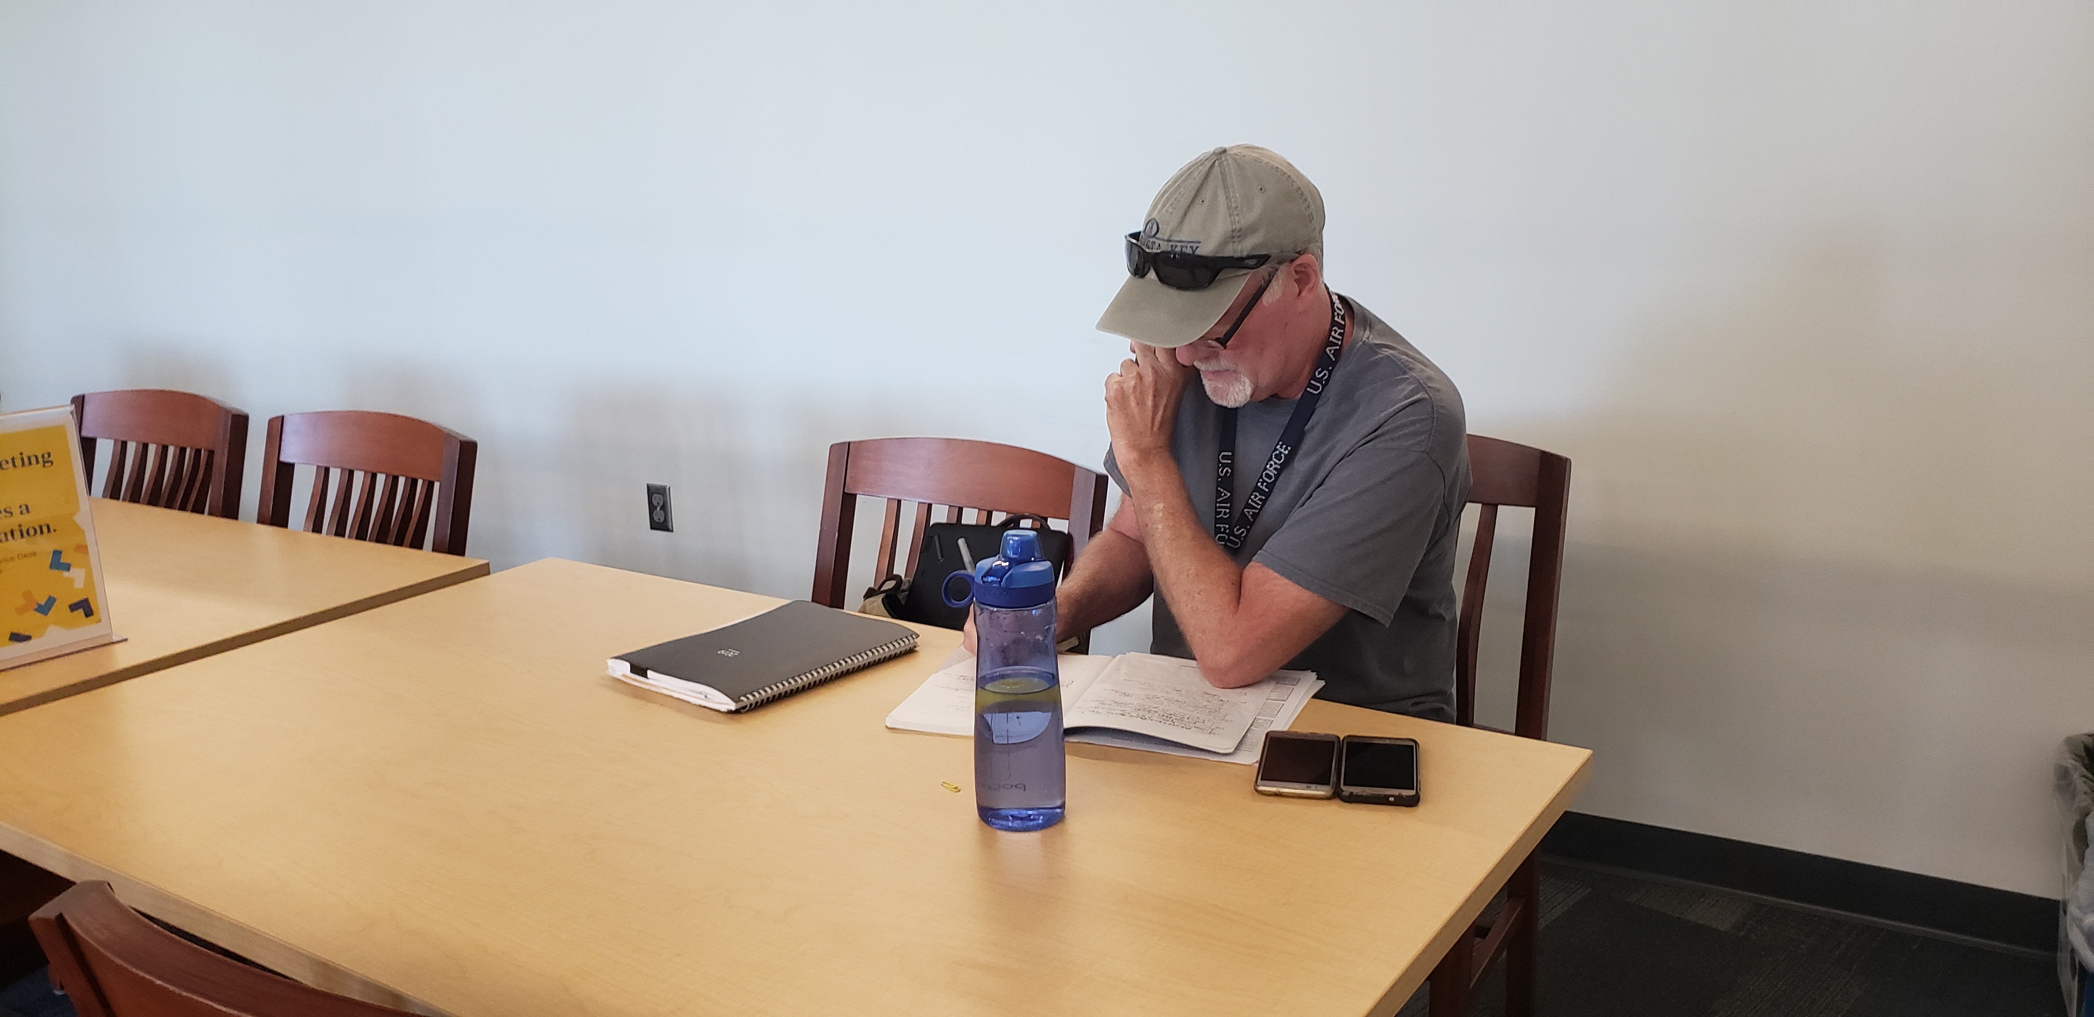
Sunday | Monday | Tuesday | Wednesday | Thursday | Friday | Saturday
 |  |  |  |  |  | 1
2 | 3 | 4 | 5 | 6 | 7 | 8
 | Rosemount: 360 Communities  12-2pm | South St. Paul Library  9:15-11:15am | Apple Valley Galaxie Library  1-3pm | West St. Paul Wentworth Library 1-3pm | Hastings Family Service  10a-12p
9 | 10 | 11 | 12 | 13 | 14 | 15
 |  |  | Apple Valley Galaxie Library  1-3pm | West St. Paul Wentworth Library 1-3pm | Hastings Family Service  10a-12p
16 | 17 | 18 | 19 | 20 | 21 | 22
 | Rosemount: 360 Communities  12-2pm | South St. Paul Library  9:15-11:15am | Apple Valley Galaxie Library  1-3pm | West St. Paul Wentworth Library 1-3pm | Hastings Family Service  10a-12p
23 | 24 | 25 | 26 | 27 | 28 | 29
 |  |  | Apple Valley Galaxie Library  1-3pm | WSP PD EVENT! Wentworth Library 1-3pm | Hastings Family Service  10a-12p
 | Rosemount: 14521 Cimarron Ave W | 106 3rd Ave N  South St. Paul | 14955 Galaxie Ave  Apple Valley | 199 Wentworth Ave E  West St. Paul | 301 2nd St E  Hastings

